Graphs

1. Make these nodes a sparsely connected graph by adding edges.
2. Make these nodes a fully connected graph. How many edges did this require?  
   Extension: mathematically how many edges in a fully connected graph with *n* nodes?
3. 1. List alternative paths between A and D.
   2. A cycle is where you take a path that ends where it started. Write one path that represents a cycle in the previous graph.
4. Complete this glossary of terms table. Complete some you can, then compare notes with a neighbour to improve your answers.

|  |  |
| --- | --- |
| **Term** | **Explanation** |
| Node |  |
| Edge |  |
| Connectedness |  |
| Path |  |
| Neighbour |  |
|  |  |
|  |  |
|  |  |

Trees

1. 1. Name 3 leaf nodes in this example of a tree.
   2. Explain how hierarchy works appropriately in this scenario.  
        
        
      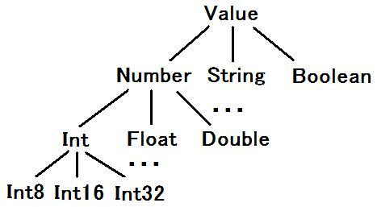

1. 1. Name a pair of siblings from this tree.
   2. State a node whose parent’s parent is 17.  
        
      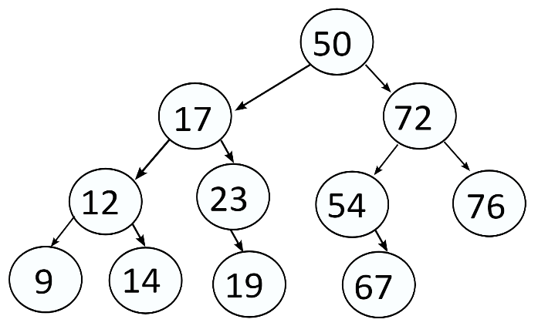
2. Write a paragraph specifically describing the trees on this page using vocabulary well: root, parent, leaf… E.g. The first tree represents ____, and it has _____ of ______ … and/or the second tree is a set of integer nodes with…